Sidramesh V H

4AL18CS082

**ASSIGNMENT**

Application Development using Python [18CS55]

Question:

Design and Implement python code for Tic Tac Toe.

Code:

#implementation of two player tic-tac-toe game in python

|  |  |
| --- | --- |
|  | ''' We will make the board using dictionary |
|  | in which keys will be the location(i.e : top-left,mid-right,etc.) |
|  | and initialliy it's values will be empty space and then after every move |
|  | we will change the value according to player's choice of move. ''' |
|  |  |
|  | theBoard = {'7': ' ' , '8': ' ' , '9': ' ' , |
|  | '4': ' ' , '5': ' ' , '6': ' ' , |
|  | '1': ' ' , '2': ' ' , '3': ' ' } |
|  |  |
|  | board_keys = [] |
|  |  |
|  | for key in theBoard: |
|  | board_keys.append(key) |
|  |  |
|  | ''' We will have to print the updated board after every move in the game and |
|  | thus we will make a function in which we'll define the printBoard function |
|  | so that we can easily print the board everytime by calling this function. ''' |
|  |  |
|  | def printBoard(board): |
|  | print(board['7'] + '|' + board['8'] + '|' + board['9']) |
|  | print('-+-+-') |
|  | print(board['4'] + '|' + board['5'] + '|' + board['6']) |
|  | print('-+-+-') |
|  | print(board['1'] + '|' + board['2'] + '|' + board['3']) |
|  |  |
|  | # Now we'll write the main function which has all the gameplay functionality. |
|  | def game(): |
|  |  |
|  | turn = 'X' |
|  | count = 0 |
|  |  |
|  |  |
|  | for i in range(10): |
|  | printBoard(theBoard) |
|  | print("It's your turn," + turn + ".Move to which place?") |
|  |  |
|  | move = input() |
|  |  |
|  | if theBoard[move] == ' ': |
|  | theBoard[move] = turn |
|  | count += 1 |
|  | else: |
|  | print("That place is already filled.\nMove to which place?") |
|  | continue |
|  |  |
|  | # Now we will check if player X or O has won,for every move after 5 moves. |
|  | if count >= 5: |
|  | if theBoard['7'] == theBoard['8'] == theBoard['9'] != ' ': # across the top |
|  | printBoard(theBoard) |
|  | print("\nGame Over.\n") |
|  | print(" **** " +turn + " won. ****") |
|  | break |
|  | elif theBoard['4'] == theBoard['5'] == theBoard['6'] != ' ': # across the middle |
|  | printBoard(theBoard) |
|  | print("\nGame Over.\n") |
|  | print(" **** " +turn + " won. ****") |
|  | break |
|  | elif theBoard['1'] == theBoard['2'] == theBoard['3'] != ' ': # across the bottom |
|  | printBoard(theBoard) |
|  | print("\nGame Over.\n") |
|  | print(" **** " +turn + " won. ****") |
|  | break |
|  | elif theBoard['1'] == theBoard['4'] == theBoard['7'] != ' ': # down the left side |
|  | printBoard(theBoard) |
|  | print("\nGame Over.\n") |
|  | print(" **** " +turn + " won. ****") |
|  | break |
|  | elif theBoard['2'] == theBoard['5'] == theBoard['8'] != ' ': # down the middle |
|  | printBoard(theBoard) |
|  | print("\nGame Over.\n") |
|  | print(" **** " +turn + " won. ****") |
|  | break |
|  | elif theBoard['3'] == theBoard['6'] == theBoard['9'] != ' ': # down the right side |
|  | printBoard(theBoard) |
|  | print("\nGame Over.\n") |
|  | print(" **** " +turn + " won. ****") |
|  | break |
|  | elif theBoard['7'] == theBoard['5'] == theBoard['3'] != ' ': # diagonal |
|  | printBoard(theBoard) |
|  | print("\nGame Over.\n") |
|  | print(" **** " +turn + " won. ****") |
|  | break |
|  | elif theBoard['1'] == theBoard['5'] == theBoard['9'] != ' ': # diagonal |
|  | printBoard(theBoard) |
|  | print("\nGame Over.\n") |
|  | print(" **** " +turn + " won. ****") |
|  | break |
|  |  |
|  | # If neither X nor O wins and the board is full, we'll declare the result as 'tie'. |
|  | if count == 9: |
|  | print("\nGame Over.\n") |
|  | print("It's a Tie!!") |
|  |  |
|  | # Now we have to change the player after every move. |
|  | if turn =='X': |
|  | turn = 'O' |
|  | else: |
|  | turn = 'X' |
|  |  |
|  | # Now we will ask if player wants to restart the game or not. |
|  | restart = input("Do want to play Again?(y/n)") |
|  | if restart == "y" or restart == "Y": |
|  | for key in board_keys: |
|  | theBoard[key] = " " |
|  |  |
|  | game() |
|  |  |
|  | if __name__ == "__main__": |
|  | game() |

|  |
| --- |
|  |
|  |

OUTPUT:

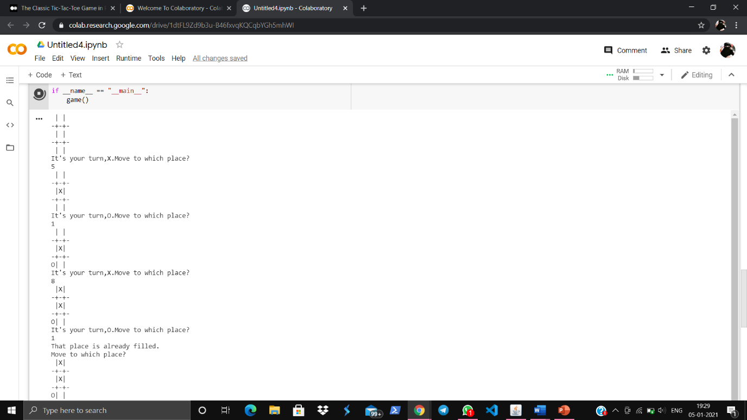

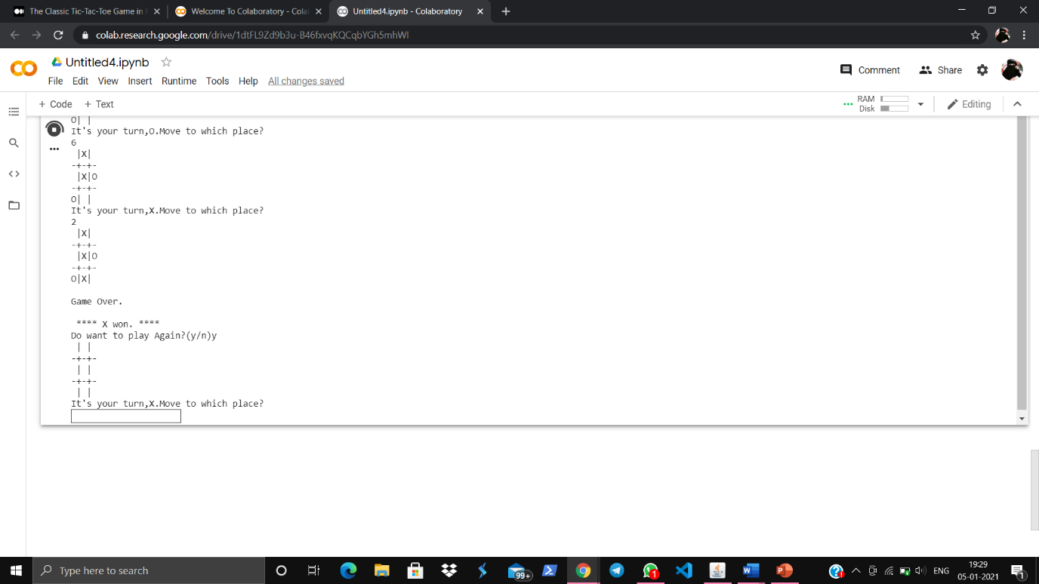

Github link: <https://github.com/ShizaAmreen/ADP-Assignment/blob/main/_Tic-Tac-Toe_>

Google Colab: <https://colab.research.google.com/drive/1dtFL9Zd9b3u-B46fxvqKQCqbYGh5mhWI>